Mathematics 1A module

Summaries and theory

Week1

This document highlights functions and models

The linear function is f(x) = mx + c

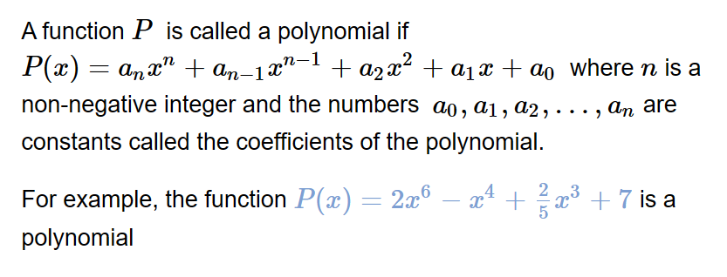

The power function encompasses f(x) = ax^n

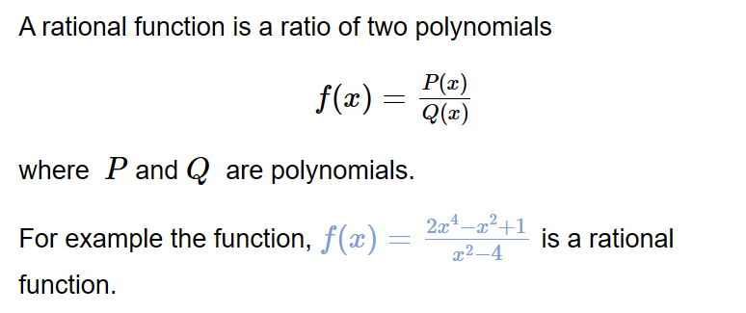

Algebraic functions encompass Poly, Power and Rational Functions.

Trigonometric functions are discussed and not summarized.

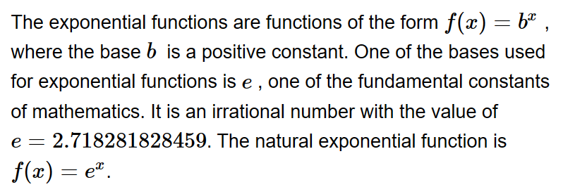

Logarithmic functions like f(x) = lnx or f(x) = ln(x)

The bottom is the given from the docs

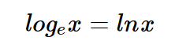

Transformations and functions

Vertical and horizontal shifts

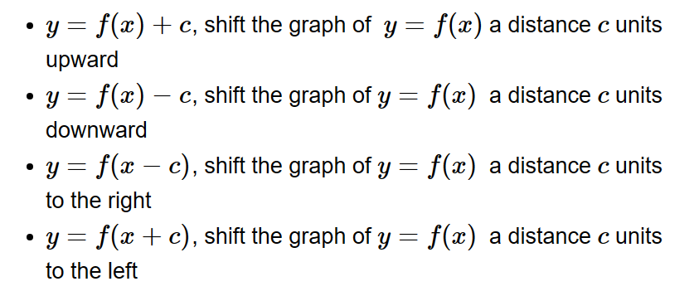

Vertical and horizontal stretching

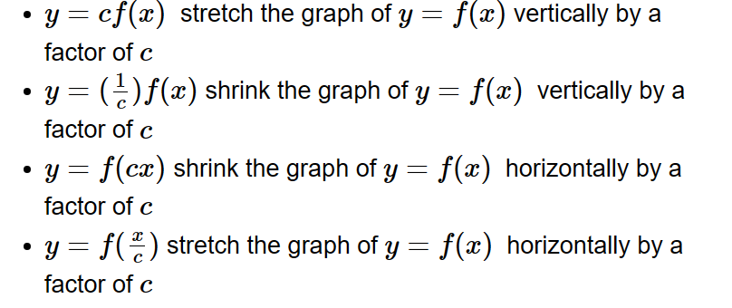

Reflecting

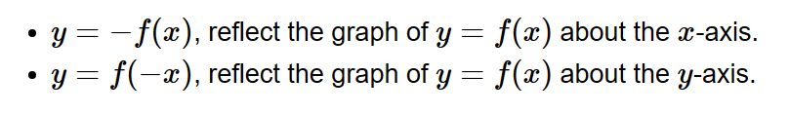

Composite functions

